Business Division | VINCI Facilities | Job Family | Operations FM
Mission and Vision | Vision - To be regarded by all our stakeholders as the leading and trusted expert in the responsible management, operation and adaption of the built environment  Mission – Create and maintain great places to live & work, listening to what our customers need and providing innovative solutions that add value, delivered by excellent people who care
Job Role | Cleaner | Grade | V1

Level of Responsibility | Responsible for completing tasks and procedures. May also be responsible for initiating tasks and procedures within limited parameters. The ability to gain a good knowledge and understanding of a subject area of work or study, and to perform varied tasks with some guidance or supervision.

WHAT WE EXPECT YOU TO DO
Summary of Role
Undertake cleaning of the establishment to ensure a comprehensive cleaning service is provided in compliance with local procedures and practices and Health & Safety Regulations. Areas to include cleaning and restocking bathrooms and fixtures, showers and including washing floors, cleaning and restocking kitchens and kitchen fixtures, cleaning OCS and communal meetings areas, cleaning offices/ meeting rooms and fixtures, vacuuming carpets, dusting, polishing and the emptying off all bins and other cleaning-related activities in accordance with instructions given by the Facilities Manager or Senior Management.

Meets Requirements: Never Occasionally Most of the time Consistently Exceeds | Review Rating
Specific Tasks and Responsibilities
- Ensuring the cleanliness and tidiness of the areas allocated for cleaning  - Awareness for COSHH (Control of substances hazardous to Health)  - Responsible for initial call out for toilet blockages and to fix accordingly  - Report to supervisor any incidents or accidents  - Report to supervisor any maintenance requirements such as light bulb replacements, leaking wash basins etc.  - Ensure compliance with all instructions relating to the use and storage of materials/equipment necessary for the performance of tasks including deliveries.  - Perform duties as per schedule in a professional manner and to the standards expected by VINCI  - Clean a variety of surfaces using correct methods in line with VINCI processes including all hard floor surfaces, carpets and upholstery.  - Emptying and disposing of all waste to the correct waste collection area in the basement including correct disposal techniques for different types of waste. i.e – recyclable, compactor, etc.  - Restock toilets, kitchens etc. to ensure an adequate supply of consumables are always available  - Maintain adequate supplies of cleaning materials and supplies, re-ordering when needed  - Use electrical or battery powered cleaning equipment’s effectively and safely  - Removal of pests and insects as deemed necessary | Click or tap here to enter text.

HOW WE EXPECT YOU TO CARRYOUT YOUR TASKS / RESPONSIBILITIES

VINCI Group Purpose
… the guiding and motivating link that pulls the organisation together to achieve success

We are a private-sector group operating in the public interest. Our purpose is to finance, design, build and manage facilities for use by businesses. communities and individuals.

The heart of our identity is the core principle of the workplace - trust, respect and mutual assistance, putting people before systems at the same time encouraging individual initiative and teamwork.

Our Values
… the principles that drive VINCI Construction UK

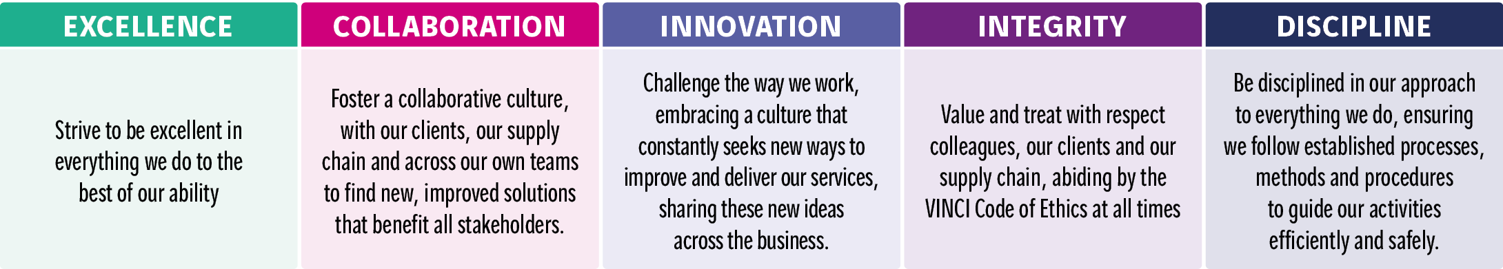

Behaviours - our Values in action
...a common language to describe the way in which individuals act or conduct themselves

Meets requirements - Never Occasionally Most of the time Consistently Exceeds
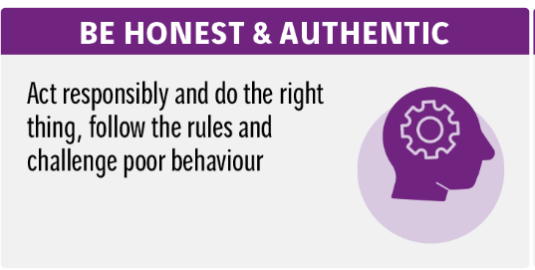 | 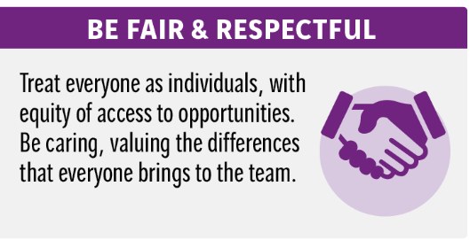 | 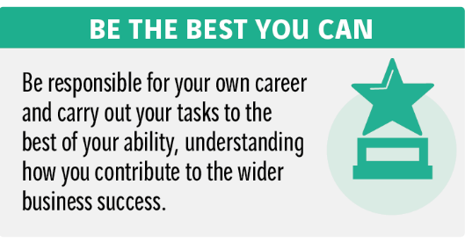
Rating: Choose an item. | Rating: Choose an item. | Rating: Choose an item.
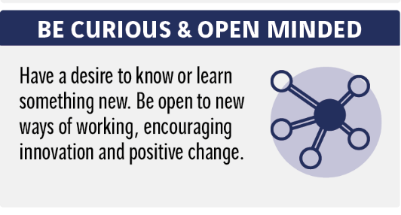 | 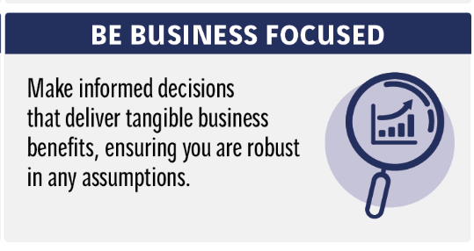 | 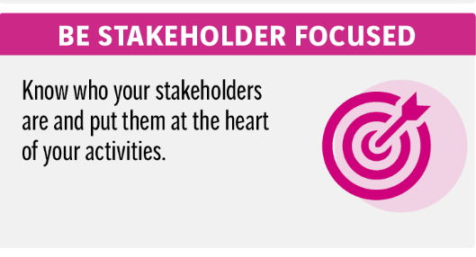
Rating: Choose an item. | Rating: Choose an item. | Rating: Choose an item.
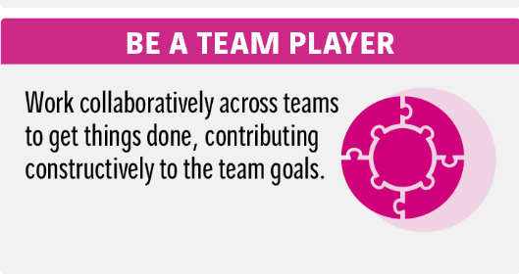 | 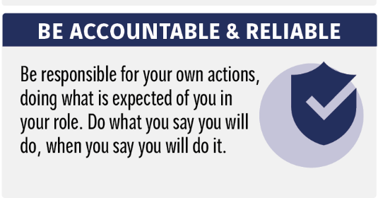 | 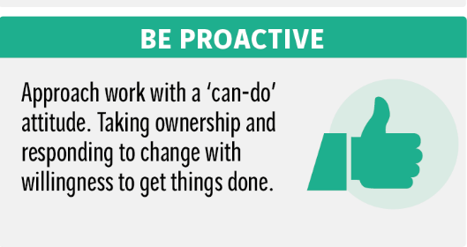
Rating: Choose an item. | Rating: Choose an item. | Rating: Choose an item.

